JOUR 4251 13.2 Personalization 2
Synced advertising
“ The practice of monitoring people’s current media behavior and using the collected information to show people individually targeted advertising based on people’s current media behavior across platforms”

How?
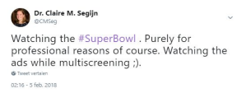
Opportunities for advertisers

1. Increased chance of exposure
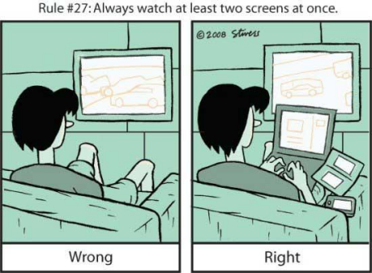

People switch
2.5x per minute
2. Chance of repeated exposure
3. Synergy effects
“Synergy occurs when the combined
the sum of their individual effects”1+1 = 3
effect of multiple activities exceeds
Barriers for advertisers
1. Capacity interference
2. Perceived surveillance & creepiness
“[Targeted advertising] is really starting to scare
people and creep them out a little bit.”
2. Perceived surveillance & creepiness
Social contract theory & Expectancy violation
● Companies that collect and use people’s data are expected to treat this data in a responsible manner through an implied ‘social
contract’
● When data is collected without people’s knowledge or consent, this social contract is violated
● Violation of social contract leads to distrust
3. Accuracy trade-off
What’s next?
Last assignments!
● Assignment #4
○ We discussed all contents needed for this assignment ○ Deadline: April 23, 2:30 pm
● Submit reading response #11
○ Articles: van Ooijen et al.
○ Deadline: April 23, 2:30 pm
Student Rating of Teaching Survey by May 3

